Council Policy No.: | CP2018-010
Council Policy Name: | Streetlight Warrant Policy
Date Approved by Council: | October 14, 2003
Date revision approved by Council: | July 17, 2018
Related SOP, Management Directive, Council Policy, Forms

Policy Statement and Rationale:
It is the purpose of this policy to establish the warrant requirements for full street lighting throughout the City of Kawartha Lakes.

Scope:
This policy shall apply to all requests for full street lighting.

Definitions:
In reading and interpreting the Streetlight Warrant policy, the following definitions apply:
- “City” means The Corporation of the City of Kawartha Lakes.
b) “Director” means the Director of Engineering & Corporate Assets.

Policy:

1. Request for Street Lights
1.01 Staff of the Engineering & Corporate Assets Department shall review the request for streetlights and apply the warrants of the Transportation Association of Canada (TAC).

2. TAC Warrants
2.01 Staff will evaluate the location requested and fill in the appropriate warrant form.
2.02 Factors that will be considered are geometrics, operational, environmental and accidents.
2.03 Staff will report on their findings to the Director for consideration.
2.04 An example of a warrant for a non-controlled access roadway is attached.

3. Warrants Met
3.01 If the warrants have been met, the Director is authorized to make the necessary arrangements for the installation of the streetlights if funds are budgeted or with the approval of the CAO.

Sample of Streetlight Warrant
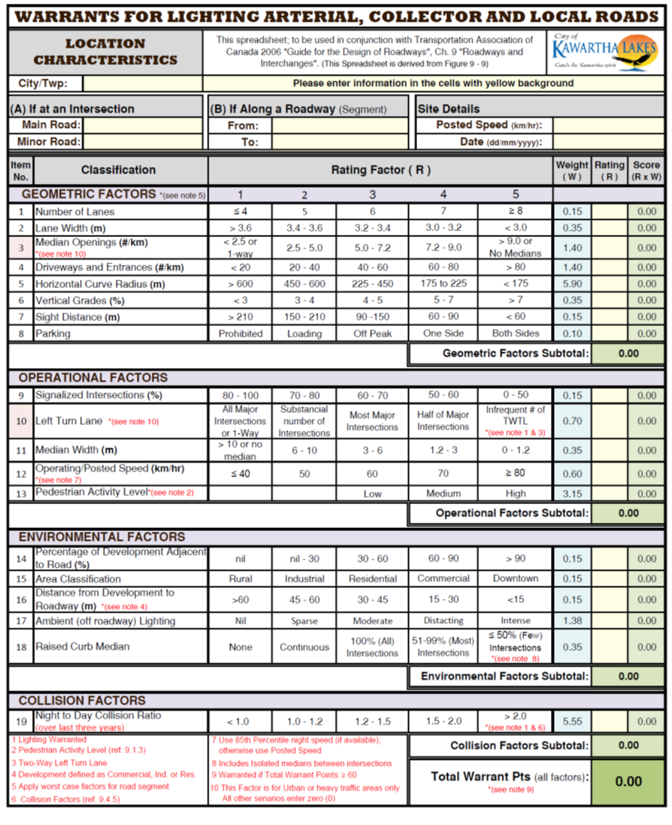

Revision History:
Proposed Date of Review:
Revision | Date | Description of Changes | Requested By
0.0 | 01/20/2021 | Updated Policy Template

