Construction Management Plan (CMP) Report [Insert Development Name and Phase]

[Month] [Day],202x

**Table of Contents**

1.0 Introduction 4

2.0 Site Description 4

3.0 Project Team and Contact Information 5

4.0 Municipal Infrastructure and Adjacent Properties Neighbourhood Pre-Condition Inspection 6

5.0 Site Access – Safety and Security 7

6.0 Operating Hours and Noise Control 7

7.0 Inclement Weather 8

8.0 Blasting and Rock Excavation – Where applicable 8

9.0 Fill Management Plan 9

10.0 Dust Control 10

11.0 Erosion and Sediment Control Measures 10

12.0 Trees 12

13.0 Erosion and Sediment Control – Operations and Maintenance 13

14.0 Project Schedule and Meetings 14

15.0 Reporting and Documentations 14

16.0 Construction Dewatering Plan 14

17.0 Conclusion 17

**List of Tables**

Table 1 – Revision Summary 2

Table 2 – Project Team Contact Information  4

Table 3 – Emergency Services (9-1-1 in the Event of an Emergency) 5

Table 4 – Cut Sources and Volume 8

Table 5 – Fill Sources and Volume 8

**List of Figures**

Figure 1- Location Plan 6

**List of Appendices**

Appendix A: Engineering Design Drawings

Appendix B: Correspondence Log

Appendix C: Resident Communication Letter

Appendix D: Pre-Condition Survey/Inspections

Appendix E: Site Signage Plan

Appendix F: Blasting Plan and Resident Blasting Communication Letter

Appendix G: Cut/Fill Plan

Appendix H: Fill Export and Receiving Site Assessment (by Qualified Person)

Appendix I: Haul Route

Appendix J: Arborist Report

Appendix K: Project Schedule

Appendix L: Construction Site Meeting Minutes

Table 1 – Revision Summary

|  |  |  |
| --- | --- | --- |
| **Date** | **Revision Title** | **Revision Summary** |
| 20xx-04-22 | Issued for 5th Submission | Updated for Development Agreement and Completion of Blasting and Deep Servicing |
| 20xx-01-14 | Issued for 4th Submission |  |
| 20xx-01-06 | Re-Issued for Pre-Servicing Agreement |  |
| 20xx-12-23 | Issued for Pre-Servicing Agreement |  |
| 20xx-12-18 | Re-Issued for 3rd Submission |  |
| 20xx-12-17 | Issued for 3rd Submission | Site Servicing |
| 20xx-11-18 | Re-Issued for Earthworks |  |
| 20xx-10-23 | Issued for 2nd Submission |  |
| 20xx-10-13 | Issued for Earthworks | Earthworks Construction |

## 1.0 Introduction

The Construction Management Plan (CMP) shall extend throughout the development and up until Final Assumption. The CMP shall be updated at every stage of development (pre-servicing earthworks, underground servicing, build-out, surface works, landscaping, etc.).

_____________ has been retained by _________________________ to prepare a Construction Management Report (CMP) in support of the proposed subdivision located in __________at the extension of and _______. The development will include the construction of ___ residential lots, roadways, sidewalks, and a variety of landscape features. The CMP has been prepared for the City of Kawartha Lakes, the project team and all other stakeholders involved with the proposed construction works. The purpose of this report is to ensure effective project communication amongst stakeholders and the public. A full set of Engineering Design Drawings is included in **Appendix A.**

This report is to be updated at each of the following project milestones that are achieved, AS APPLICABLE:

* + - Erosion and sediment controls measures to support earthworks construction
    - Site clearing and topsoil stripping
    - Earthworks excavation and structural subgrade import, placement and compaction
    - Bedrock removal via blasting
    - Completion of site servicing – water, sanitary, storm sewer installation
    - Base asphalt
    - House construction
    - Grading, fencing and landscaping
    - Surface asphalt
    - Stormwater Management Facility clean-out

The next project milestone includes the commencement of road building and shallow utilities construction.

Communications during the construction program are located in the Correspondence Log in **Appendix B**.

## Site Description

The proposed development is a hectare parcel of land located in , Ontario in the City of Kawartha Lakes. The subject site is bounded to the north by , to the west by _______________, to the east by and to the south by . The location of the subject property is identified in the **Location Plan** included as **Figure 1**.

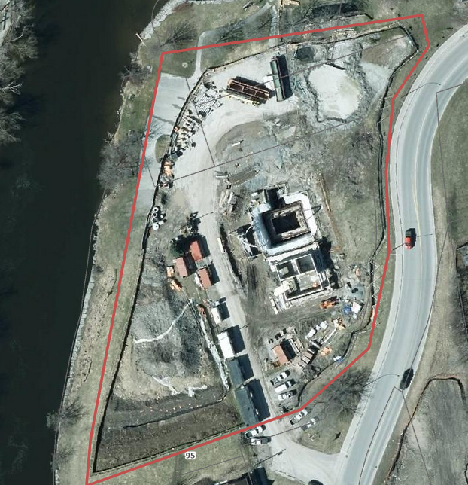

Figure 1- Location Plan

## 3.0 Project Team and Contact Information

Contact information for the project team and local emergency services are presented below.

Table 2 - Project Team Contact Information

| **Title** | **Company** | **Contact Phone Number\*** | **Contact E-Mail Address\*** |
| --- | --- | --- | --- |
| Owner |  |  |  |
| Engineering Consultant |  |  |  |
| Geotechnical Engineer |  |  |  |
| Environmental Consultant |  |  |  |
| Legal Surveyor |  |  |  |
| Earthworks Contractor |  |  |  |
| Servicing Contractor |  |  |  |
| Blasting Contractor |  |  |  |
| Monitoring Consultant |  |  |  |
| City of Kawartha Lakes Staff | City of Kawartha Lakes |  |  |
| Conservation Authority |  |  |  |
| Hydro One | Hydro One |  |  |
| Utility Contractor |  |  |  |

*Ensure that all contact numbers are up to date. Contact numbers must be changed if contacts for developers or contractors change.

Table 3 – Emergency Services (9-1-1 in the event of an emergency)

| **Emergency Service Type** | **Closest Emergency Service Facility** | **Non-Emergency Phone Number** |
| --- | --- | --- |
| **Fire** | Kawartha Lakes Fire and EMS Station 1 | 705-324-5731 |
| **Municipal Police** | City of Kawartha Lakes Police Services | 705-324-6741 |
| **Provincial Police** | Ontario Provincial Police | 1-888-310-1122 |
| **Hospital** | Ross Memorial Hospital | 705-324-6111 |

Written communication in the form of a Notification Letter will be prepared jointly by the Owner, the Design Engineer and the Contractor during each stage of construction (earthworks, construction, etc.), hand delivered to homeowners and emailed to City of Kawartha Lakes staff, local Councillors, and other applicable parties including, but not limited to, the properties abutting the development lands and along the site access from _____Street to Street ________.

A notification letter prepared by _______ for site servicing construction was hand delivered to all properties on _______ Street and ______ Street. A copy is provided in **Appendix C.** The construction notification letter includes site contact information, a general description of the proposed works and the project schedule.

## Municipal Infrastructure and Adjacent Properties Neighbourhood Pre-Condition Inspection

___________on behalf of the Owner has conducted a pre-condition inspection of construction works before the commencement of earthworks import to the site. The pre-condition inspection limits included ______________________________, through to _______, including ___________, and the properties fronting _____________________ abutting the development entrance. The pre-condition inspection included date stamp pictures of the asphalt, concrete curb, sidewalk, asphalt driveways, boulevards, trees, fences, and any other locations that may be damaged due to the construction traffic. Any existing damage was photographed and detailed in a Site Visit Report. All pre-condition reports shall be included in **Appendix D.**

The Contractor is to inform the Engineer of Record of any complaints brought to their attention. Complaints will be resolved between the Contractor, CKL, the Owner, and the Engineer of Record depending on the nature of the complaint. Pre-blast survey and notification requirements are identified below.

## Site Access – Safety and Security

Project Description Signage is installed at ________________ to inform the public about the project.

All construction heavy truck access will be restricted to one main construction entrance, as per Draft Plan Condition ##.

________ will remain the primary access to the site with the intent of minimizing site access locations in order to minimize disruption to the existing neighbourhood. The entrance is constructed complete with mud mat and signage and shall be maintained throughout the duration of construction. Signage at the construction access shall be installed as per **Appendix E**.

The Contractor and all sub trades shall avoid parking on _______________. All vehicle parking and/or material storage in relation to the proposed construction works shall be located on the proposed site. Material storage and parking locations shall be approved by the Engineer of Record and are to be consistent with all contract drawings.

The Contractor shall provide and maintain security and safety measures on the site during the construction period. All provincial and municipal regulations for workplace and personnel safety are to be maintained at all times.

________________ and ______ Streets shall be swept clean at the end of each work day. It shall be the responsibility of the Contractor to ensure that all equipment and gates are locked and secure at the end of each work day.

## Operating Hours and Noise Control

The Contractor is responsible for noise control throughout the duration of construction in compliance with the City of Kawartha Lakes By-Law 2019-124 A By-Law to Regulate Noise in The City of Kawartha Lakes, as amended. All efforts shall be made to minimize noise created by construction activities in an effort to mitigate noise pollution to neighbouring areas. It is noted that there is a residential neighbourhood directly adjacent the site and all efforts to not disturb residents with excess noise should be made. The Contractor is to notify the Engineer of Record and CKL of all complaints of noise.

The earthworks stage of construction has been completed. The second stage, site servicing underground and surface works began on 202X. The blasting program was completed on January 29th, 202X.

The normal operating hours for on site construction will be from 7:00 to 21:00 Monday to Friday, excluding statutory holidays, and including some Saturdays.

Should construction activities need to extend to a Sunday or statutory holiday or exceed normal operating hours, the Contractor shall notify the Engineer of Record, who will contact the City of Kawartha Lakes with a formal request for exemption in accordance with the City of Kawartha Lakes By-Law 2019-124 A By-Law to Regulate Noise in The City of Kawartha Lakes, as amended, for City review and approval.

## Inclement Weather

The Contractor is responsible for maintaining site conditions under inclement weather conditions. Typical inclement weather conditions include large rainstorm events and drainage run-off, given the time of year. Servicing construction may incur rainstorm events in addition to high winds under dry weather conditions, the Contractor shall employ dust inhibitors and the application of water at the direction of the Engineer of Record. In the event of storm events the Contractor shall ensure that erosion control measures outlined in the erosion control plan are in place and functioning as intended and shall provide notice to the City of Kawartha Lakes a minimum of 24 hours in advance that inclement weather measures are in place. Soil moisture conditions shall be monitored by the Geotechnical Engineer as part of the fill placement program to ensure that proper compaction and moisture content is achieved. The following procedures shall be implemented for inclement weather events:

* + 1. Significant rain event – (address onsite & off-site conditions, ESC, CBs, culverts, notifying existing residents, etc.)
    2. Significant wind event – (address onsite & off-site conditions building materials, garbage, dust, etc.)
    3. Significant snow event – (address onsite & off-site conditions, ESC, CBs, culverts, existing residents, municipal access, access to water servicing infrastructure, storm servicing infrastructure/SWM facilities, etc.)
    4. Significant snow melt/thaw event – (address onsite & off-site conditions, ESC, CBs, culverts, storm servicing infrastructure, SWM facilities, existing residents, etc.)

## Blasting and Rock Excavation – Where applicable

Bedrock was incurred on-site within the zone of trench excavation, in the vicinity of ______ west of _______. Bedrock was excavated via a combination of rock hammering at the site entrance and blasting on-site.

The blasting and blast design was completed by _________________ and a pre blast survey was completed by ______ Inspections. The blast design, pre blast survey, notification schedule etc. were in accordance with OPSS.MUNI 120. Documents related to the record of experience and qualifications of the blaster, as outlined in OPSS.MUNI 120, have been prepared for _____________________ and were previously submitted to CKL. A copy of the blast design and a signed letter from the Blaster indicating agreement with the blast design was also submitted to CKL. The pre blast survey was conducted as per OPSS.MUNI 120 and was completed on , 202X. Notification of the Pre-Blast survey was provided to all owners, and tenants of improved properties within 250m of the blast in the form of a notification letter on , 202x. Vibration monitoring equipment was in place during all blasting and proof of calibration as well as the record of experience and qualification. Inspections were submitted to CKL.

Notification of blasting was provided in the form of a notification letter to all owners, and tenants of improved property within 250m of the blast on ___________ and ___, 202x. A copy of the notification package distributed to residents is included in **Appendix F**. As per OPSS.MUNI 120, all utilities within the same radius were notified via Ontario One Call on _______,202x.

## 9.0 Fill Management Plan

The proposed development earthworks program and Cut/Fill Plan is provided in **Appendix G**. Earthworks volume quantities are per the following:

Table 4 – Cut Sources and Volume

| **Cut Source** | **Contractor** | **Cut Volume** |
| --- | --- | --- |
| Earth Excavation |  |  |
| Existing Topsoil Pile |  |  |
| Stripping (0.3m average) |  |  |
| Trench Excess Surplus |  |  |
| **Total Cut** |  |  |

Table 5 – Fill Sources and Volume

| **Fill Source** | **Contractor** | **Fill Volume** |
| --- | --- | --- |
| Total Cut to Fill (Above total) |  |  |
| Infiltration Trench Granulars |  |  |
| Import Structural – XXXXX |  |  |
| Import Structural Fill – XXXXX from XXXXX Street |  |  |
| Import Structural Fill – Owner from Pit |  |  |
| **Total Fill** |  |  |

Fill export and receiving site(s) for fill material removed from this development have been assessed and complete review of the receiving site and submission to the City have been provided by the Engineer of Record/Geotechnical Qualified Person (QP), and is specific to the receiving site location. See **Appendix H** for Fill Export and Receiving Site Assessment, as per City of Kawartha Lakes requirements and City by-law 2019-105.

Should further import fill be required then subgrade quality and fill compaction verification shall be managed by the Geotechnical Engineering firm ___________. To ensure subgrade quality and compaction comply with design specifications, exposed native subgrade shall be inspected prior to placement of any fill. All lifts of fill will be tested for compaction prior to placement of additional lifts. In order to maintain an adequate level of quality verification, a [Geotechnical Firm] representative shall be on-site during any earthworks structural material placement. Should additional site visits be required the Owner and/or Contractor shall notify the Geotechnical Engineer a minimum of 24 hours in advance of placing any new lift of fill on exposed subgrade or previous lifts of fill that have not been verified.

All relevant parties shall be notified by the Owner and/or Contractor a minimum of five (5) business days prior to the import of fill from any new source.

All fill imported to site shall be logged by the Owner and/or Contractor upon receipt at the site, noting the source of each load of fill. In order to provide quality verification of the subgrade below existing lifts of fill and compaction of existing fill on site, ______will be required to advance test pits within the fill to inspect subgrade in areas not previously tested and test compaction as required. Non-structural material shall be placed in areas of non-structural fill and at the direction of the Geotechnical Engineering Firm.

## 10.0 Dust Control

Maintaining proper air quality by providing sufficient dust control in and around the construction site will be the responsibility of the Contractor. A dedicated onsite water truck shall be onsite at all times during earthworks and available when necessary for dust control. In addition, the Contractor may be required to use dust inhibitors at the direction of the Engineer of Record.

## 11.0 Erosion and Sediment Control Measures

The development of the site, particularly the stripping of the site, will result in an area of exposed native soil, which in turn has the potential to erode and contribute sediment to downstream receivers. To mitigate these effects, an erosion and sediment control strategy was developed for the site. Elements of the strategy incorporate best practices as outlined in the Erosion and Sediment Control Guidelines for Urban Construction, (2019).

The erosion and sediment control plan has been established to best protect downstream receivers – ____________________ - during the construction period. A silt fence barrier will first be erected downgrade of the construction area. After the silt fence is in place the mud mat will be installed at the construction entrance. Erosion and sediment control features, including the intended purpose, are identified below.

**Heavy-Duty Silt Fence**

Heavy-Duty Silt fence will be utilized for all silt fencing, including as a perimeter control and will be installed as shown on the **Erosion & Sediment Control Plan (included with the engineering drawing set)**. Silt fence will be installed in accordance with OPSD 219.130 and may require periodic maintenance during the construction period. All silt fence shall be double layered when placed adjacent to sensitive receivers, water courses, and homeowners’ property.

**Catch Basin Filter Cloth** **(CB Filter Cloth)**

Catch basin filter cloth shall be used to accumulate any downstream sediment from entering regulated drainage areas or municipal infrastructure.

**Haul Route**

The proposed haul route shall be provided to the City of Kawartha Lakes prior to any commencement of hauling activities. The haul route shall outline the proposed routes, trucks used, quantity of material, schedule, location of disposal and receiving site, and required testing. See **Appendix I** for the Haul Route Drawing.

**Mud Mat**

A mud mat will be installed at the construction entrance to the site as shown on the **Erosion & Sediment Control Plan**. The mud mat will consist of a rolled Nilex mud mat, stone mud mat, or approved equivalent. The mud mat will require periodic maintenance during construction; if it becomes clogged the contractor can maintain the mat by “turning” it or adding additional rip rap as needed to maintain the effectiveness of the mat.

**Hydroseeding of Topsoil Stockpile**

Once the topsoil stockpile is completed it shall be hydroseeded within 30 days to prevent erosion. The hydroseed mix will be a standard grass seed mix with mulch to promote growth and reduce erosion.

**Interceptor Swales**

A variety of interceptor swales will be implemented during the construction period. The purpose of these swales will be to intercept and convey runoff within the site to the Temporary Sediment Pond.

**Permeable Barriers**

Straw bales or rock check dams have been included in the proposed conveyance swale as a means of reducing the velocity in the swale. They will be installed in accordance with OPSD219.180 and the Contractor shall maintain the check dams during construction.

**Temporary Sediment Pond**

A temporary erosion and sediment control pond has been designed for the construction period. This pond will have contributing drainage from the entire site area. The pond construction was modified to suit existing bedrock surface, and approval confirmed by CKL and documented in the correspondence log.

The temporary erosion and sediment pond shall be monitored for sediment build up. As identified in the Erosion and Sediment Control Guidelines for Urban Construction, sediment accumulation in the pond must be measured a minimum of every 6 months. The pond shall require cleanout when sediment accumulation reaches 50% of the forebay design capacity. The temporary erosion and sediment pond is to be de- commissioned prior to lot XX building permit issuances. Sediment removal, testing, and disposal shall be in accordance and at the direction of the Environmental and Geotechnical Consultant, ________________. All sediment removal is to be disposed of at a Class 1 soil management site, landfill, or dump and not reused on site. At a minimum, upon de-commissioning or sediment removal, the sediment shall be tested for the following parameters:

* Petroleum hydrocarbons (F1 through F4) including benzene, toluene, ethylbenzene, xylenes;
* Metals and hydride-forming metals (antimony, arsenic, barium, beryllium, boron, cadmium, chromium, cobalt, copper, lead, molybdenum, nickel, selenium, silver, thallium, uranium, vanadium, and zinc);
* Polycyclic aromatic hydrocarbons (PAHs);
* Electrical conductivity (EC), sodium adsorption ration (SAR) and cyanide; and
* Leachate analysis.

All parameters must be below the acceptable concentrations for disposal as outlined in Rules for Soil Management and Excess Soil Quality Standards prepared by the Ontario Ministry of Environment, Conservation and Parks, dated 2019. The sampling frequency shall be based on stockpile soil volume in accordance with O.Reg. 153/04.

## 12.0 Trees

Tree removal shall be performed according to the Arborist Report and Tree Inventory and Preservation Plan, prepared by XXXXX and provided in **Appendix J.**

INSERT ADDITIONAL SITE SPECIFIC INFORMATION – identify trees for protection (e.g. trees on property line, butternut trees, etc.), tree protection fencing or other means of tree protection, methods for avoiding tree or root damage during construction, etc.

Tree removal shall be performed according to the Migratory Birds Regulations (2022) and Migratory Birds Convention Act (1994). All tree removal shall be performed to avoid peak nesting season.

## Erosion and Sediment Control – Operations and Maintenance

All erosion and sediment control operations and maintenance specifications shall be site specific.

As identified on the erosion and sediment control plan the following notes shall be adhered to:

1. The proposed works shall be carried out in such a manner that a minimum amount of erosion occurs and such that sedimentation facilities control any erosion that does occur. Topsoil stripping shall be limited to areas set for immediate construction.
2. Temporary siltation control devices are to be constructed before construction starts and maintained for the duration of construction until removal.
3. Sediment accumulation of more than 0.3 metres is to be removed immediately.
4. Inspection of silt fencing is to occur after every significant rainfall event and maintained as required, or at the direction of the engineer.
5. Additional erosion and sediment control materials (silt fence, clear stone, etc.) are to be kept on site for emergencies and repairs.
6. Erosion and sediment control methods are to be continuously evaluated and upgrades are to be implemented when necessary.
7. Ensure that appropriate response is taken for spills and any incidents are properly documented and reported.
8. At the completion of construction, any excess material shall be removed from the site.
9. Silt fences, mud mat, filter fabric and any other erosion/siltation control measures shall be removed once all construction had been completed and all vegetation has been established at the direction of the engineer.
10. Topsoil stockpiles are to be hydro seeded if topsoil starts being windswept onto adjacent properties.

## Project Schedule and Meetings

Deep servicing construction was completed on _______,202x. Surface work construction is expected to begin _______, 202x. A schedule outlining key dates is included in **Appendix K**. Schedules may be submitted either as Gantt charts or as sequences of events.

Construction meetings between CKL, the Contractor, the Owner, and the Engineer of Record generally occur approximately every two weeks during the duration of site servicing construction. Meetings have been held on site unless otherwise agreed by attendees and led by the Contract Administrator (Engineer of Record) for the project. The Engineer of Record generally issues meeting minutes within 48 hours of each progress meeting. Should additional meetings be required they will be arranged on an as required basis. Construction meeting minutes are included in **Appendix L.**

## Reporting and Documentations

Inspection reports will be prepared by the Site Inspector to document construction progress and any approved design changes to the project. Progress reports shall be forwarded to the project team weekly, bi-weekly, or monthly, subject to status of project/activity.

The Contractor shall collect digital as-built data, and the Site Inspector will confirm constructed as-built data as construction progresses and upon the completion of construction. As-built data will be transferred onto the design drawings for submission to CKL once all construction is complete. As-built information to include but not be limited to the following:

* 1. Site inspection reports;
  2. Geo-technical material testing results and reports
  3. CCTV inspection reports of all sewer (hard copy and/or digital)
  4. Any watermain testing results per CKL standards and protocol
  5. Sanitary testing (deflection testing, low pressure air testing)

## 16.0 Construction Dewatering Plan

**Dewatering Plan**

**Methods**

It is understood that pumping from sumps within the excavations would be the Contractor’s preferred method to control groundwater inflow and incident precipitation into the excavations (all applicable agencies shall be notified and permits acquired prior to commencing of any dewatering works).

**Proposed** **Drainage** **Outlets**

All dewatering systems (e.g. in-excavation pumps) must discharge via a temporary pipeline/ditch to a pre-treatment system (e.g. filter bags fitted on outlet pipe) to control Total Suspended Solids (TSS) to within the applicable discharge criteria; either the City of Kawartha storm sewer standards or TSS and turbidity limits as discussed in the hydrogeology report.

The discharge release will be conducted in a manner that prevents erosion or soil scour at the point of discharge and along the flow path. The discharge location shall be inspected for existing sediment accumulation at the start of pumping and daily during dewatering operations.

Dewatering and discharge will have to be in compliance with Municipal by-laws and regulations, e.g. City of Kawartha Lakes By-Law 2016-006.

**Permit** **to** **Take** **Water**

______________ have completed a Preliminary Geotechnical Investigation and Slope Stability Analysis (August 20xx) for the _______ North development. This report states that dewatering during construction from excavations in glacial tills and clayey soils should generally be able to be handled by pumping from sumps within the trench excavations. For excavations below the water table, more positive dewatering measures may be required in addition to pumping from sumps. It is noted that water takings in excess of 50,000 L/day will qualify for self-registration on the Ministry of Environment, Conservation and Parks (MECP)’s Environmental Activity and Sector Registry (EASR). A dewatering assessment was also completed by ________ for the SWM Pond S (located within Phase 2 of the ______ South development) and it was determined that the initial and steady state factor of safety dewatering rate (one order of magnitude higher for hydraulic conductivity) were 56,305 and 84,458 L/day, respectively. Given that the ______ South Phases 1 and 2 will be in an overall fill area, there will be negligible dewatering contributions from the installation of sewers and watermains.

Initial and steady state factor of safety dewatering for the basement excavations has been estimated to be 7,152 and 4,768 L/day, respectively, per detached lot and 10,203 and 6,802 L/day for Townhouse Block , respectively. House/Townhouse construction and basement excavations will occur after earthworks and underground servicing are complete and as such dewatering for these activities will not occur concurrently and dewatering will be staged such that the water taking is less than the 400,000 L/day rate that triggers the MECP EASR Permit to Take Water process. However, an EASR is required if the combined rates are less than 400,000 L/day. The EASR registration requires dewatering and discharge plans to be prepared by qualified professionals and can be submitted shortly prior to the start of dewatering without agency review

**Impact** **on** **Surrounding** **Wells**

___________ completed a Hydrogeological Study for the _______ lands on ______20xx. From this study, 112 water wells were reported within a radius of 500 metres, of which 41 were considered abandoned according to Ontario Regulation 903. Of the remaining wells, 66 are listed for domestic, livestock or public water supply purposes, and 3 are listed for commercial use.

The hydrogeological assessment by _________ examined the water well records on file with the MECP for an area extending 500 m from the site limits. Thirty-seven (37) water supply wells were identified in the MECP water well records drilled between 1952 and 2006. Records show that thirty-five (35) of these were used for domestic and agricultural water supply, while two records identify a commercial water supply use (drilled in 1956 and 2006). The study noted that groundwater well monitoring and mitigation measures during construction will also be required and will need to be identified in the application.

**Dewatering** **Plan** **and** **Best** **Practice**

As mentioned above, the steady state groundwater flow is anticipated to be less than 400,000 L/day for both North and South developments. During significant rainfall events, the following monitoring program is recommended, as follows:

The contractor to provide measurement controls suitable to measure and record:

1. Daily volume of water discharged if any (e.g. totalizer);
2. Quality sampling (during rain events):
   1. In-situ water quality (turbidity, pH and temperature) is to be taken by the site supervisor; and
   2. Collection and submission of treated discharge water quality samples for laboratory analysis to be taken on an as required basis to confirm compliance with City of Kawartha Lakes By-law 2016-006 (Management and use of the Sewer Works).
3. At all times, sediment control measures should be implemented to control the concentration of TSS in the discharge water such that it remains within the applicable guidelines; and,
4. Visual inspection of the discharge water shall be conducted at least once daily to ensure there is no visible oil, sheen or suspended sediment.

## 17.0 Conclusion

This Construction Management Plan has been prepared to ensure an effective communication tool in the safe and timely construction of all works, in support of the proposed development. The CMP represents a living document that is reviewed and updated throughout the site development.

Prepared by: Reviewed by:

**Acknowledgement:**

The Owner and Engineer of Record acknowledges that the construction management plan will be adhered to and in the event issues/complaints are not addressed in the time frames noted or to the satisfaction of the City, the City can immediately stop all works and any charges incurred by the City, including administration fees, will be invoiced back to the owner

Date:

Owner:

Date:

Engineer of Record:

Appendix A: Engineering Design Drawings

Appendix B: Correspondence Log

| **Date** | **Correspondence Description** |
| --- | --- |
| 20XX-XX-XX | E.g. Confirmed delivered of residence notification letters |
| 20XX-XX-XX | Confirmed beginning of street cleaning |
| 20XX-XX-XX | Announced beginning of transit trucks importing materials to site |
| 20XX-XX-XX | Announced connection of stormwater pond Hickenbottom drain to existing sewer |
| 20XX-XX-XX | Provided correspondence regarding received complaints regarding construction noise |
| 20XX-XX-XX | CKL email response regarding construction noise complaints |

Appendix C: Resident Communication Letter

Appendix D: Pre-Condition Survey/Inspections

This inspection was performed to inspect the condition of existing municipal infrastructure at the corner of XXXXX Street and XXXXX Road in support of the proposed XXXXXX Subdivision. On XXXXX XX, 20XX, a representative from XXXXX took photographs and notes on the condition of the existing road, shoulders, curbs, sidewalks, and catch basins in the municipal right-of-way.

A sample of a subject site for a pre-condition survey.
Subject Site Property

a sample of a possible defect to note on a pre-condition survey,


Asphalt Cracking on XXXXX Street

another example of a possible defect to note on Pre-Condition Survey


Asphalt and curb cracking on XXXXX Road

Appendix E: Site Signage Plan

**Project Notification**

**XXXXX Engineering**

**Take Notice** that [INSERT DEVELOPER NAME] Engineering has begun construction of [INSERT PROJECT DESCRIPTION]. This site shall remain secure when not in operation.

**CONSTRUCTION IN PROGRESS**

**Site Location:**

**Developer Contact Name:**

**Phone Number:**

**After Hours Contact:**

**Email:**

**Website:**

**Commencement Date:**

**Anticipated Completion Date:**

This sign should be placed as near the street line as feasible so the public can see the sign and make note of the contact information should they wish to make enquiries. The sign shall be posted at least 1 metre above grade at the entrance to the site. The sign shall be approximately 3.7m x 2.3m in size. Signs shall not be attached or nailed to trees.

Appendix F: Blasting Plan and Resident Blasting Communication Letter

Appendix G: Cut/Fill Plan

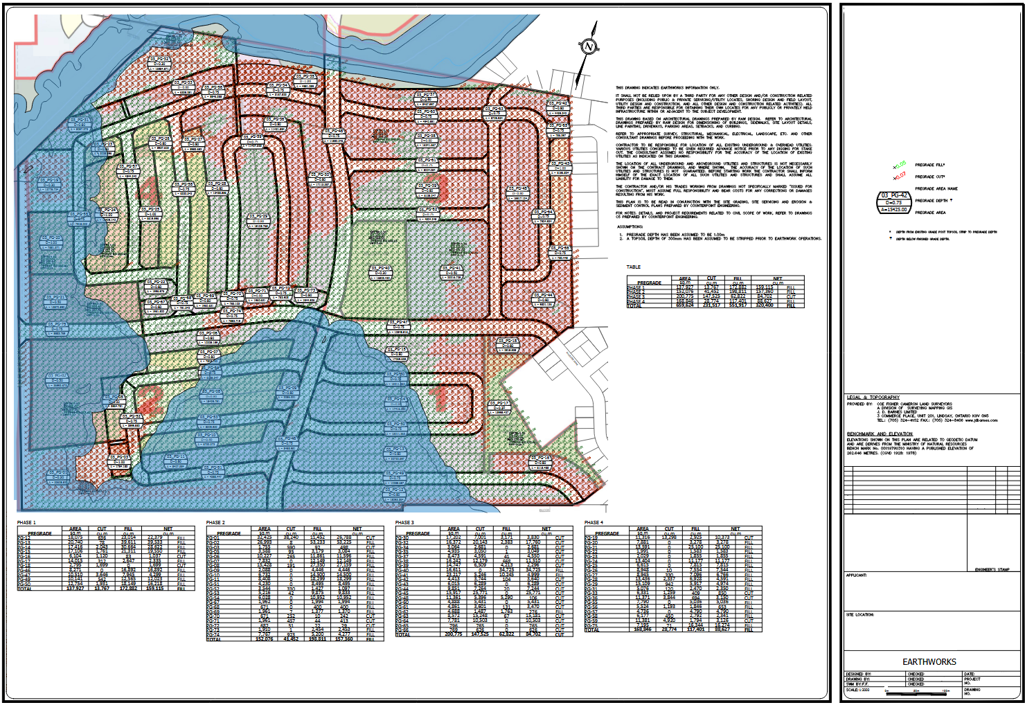

Appendix H: Fill Export and Receiving Site Assessment (by Qualified Person)

Appendix I: Haul Route

Appendix J: Arborist Report

Appendix K: Project Schedule

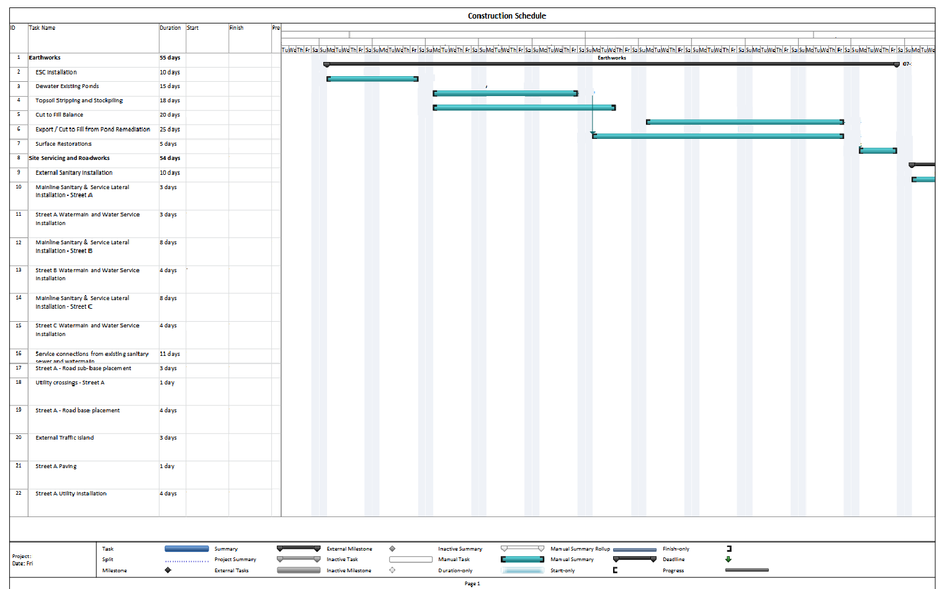

Appendix L: Construction Site Meeting Minutes