Operations, Monitoring and Maintenance (OMM) Guide for Homeowners to Provide Assistance with their Private Stormwater Management Infrastructure

Requirements

* Introduction (provide a conversational tone directly addressing homeowner)
* Low Impact Development (LID) feature descriptions and detail drawings
* Inspection and maintenance procedure in list format
* Inspection template checklist
* Map of subdivision with relevant design feature locations highlighted
* Table including home addresses and the design features that are constructed on each lot

Example OMM Guide for Homeowners

Dear Homeowner:

As you read this document, you will learn that your home purchase includes Insert LID Feature designed to meet the latest drainage guidelines and standards of the Kawartha Region Conservation Authority, the City of Kawartha Lakes and the Ministry of Environment Conservation and Parks (MECP) design criteria. Your property is directly contributing to the environmental guidelines required as a result of development.

Low Impact Development (LID) refers to a stormwater management approach aimed at reducing the negative effects of increased runoff and pollution by controlling stormwater near its source (promote the rainfall remaining where it falls). LID involves various site design techniques that limit runoff, along with small-scale, distributed practices that imitate natural or pre-development hydrological processes such as infiltration, evapotranspiration, water storage, filtration and stormwater detention.

This Guide for Homeowners is prepared to assist new homeowners (you) in the ongoing operation, monitoring and maintenance of the stormwater management infrastructure on your property. This Insert LID Feature is part of an overall stormwater management strategy implemented within Insert Development. The Insert LID Feature is an integral part of the storm drainage system put in place to control drainage run-off, promote infiltration, and convey flows within the Insert Development. This Guide is intended to provide awareness about how your actions can impact the stormwater resources and options for decision making. Homeowners are encouraged to take appropriate safety measures when assessing the condition of the Insert LID Feature for required maintenance. If the Insert LID Feature is unsafe to maintain on your own, please seek professional help.

The homeowner is responsible to maintain the Insert LID Feature to maintain the overall integrity of the system by maintaining the infrastructure on their property. The Insert LID Feature is not to be altered, changed, or removed. Doing so, may impact the function of the stormwater management system and could lead to localized flooding.

This Guide is not a legal agreement (refer to your purchase and sale agreement and title registration documents for any legal stipulations and requirements). Rather, this Guide provides information to help assist you in assessing the condition and maintenance of your Insert LID Feature.

Any costs and expenses related to the ongoing maintenance, repair, or replacement of the Insert LID Feature shall be borne by the property owner. The Insert LID Feature is not to be used for personal disposal, altered or removed, and no structures are to be placed on or within the Insert LID Feature. Additionally, the grades within the swales shall not be altered. The Insert LID Feature is designed to accept drainage from your property and adjacent residential properties.

A table has been prepared which identifies the properties which contain Insert LID Feature, the properties which contribute drainage to each Insert LID Feature and the direction of surface flow, see **Appendix A**.

(Replace this section with information about specific LID feature. An infiltration trench is used for example.)

**What is an Infiltration Trench?**

An infiltration trench is a stone filled trench complete with a perforated underdrain pipe that is designed to infiltrate clean surface runoff from rooftops and rear yards into the ground.

**How does it function?**

Stormwater runoff is directed to the trench which then promotes infiltration of the runoff back into the ground. The runoff being captured and infiltrated by the trenches is generally from downspouts from roof runoff and rear yard drainage and is considered “clean water” with minimal suspended solids (e.g. silt, organic matter, etc.). They provide groundwater recharge and quality treatment for runoff and provide a similar process to the natural hydrologic cycle. Trenches are designed to infiltrate smaller rain events and have raised overflow catch basins that are designed to take large storm events out to the storm sewer system.

**Where is the trench located?**

Infiltration trenches are located in the rear yard of the properties.

**What does the trench look like?**

A typical detail of the infiltration trench is included below:

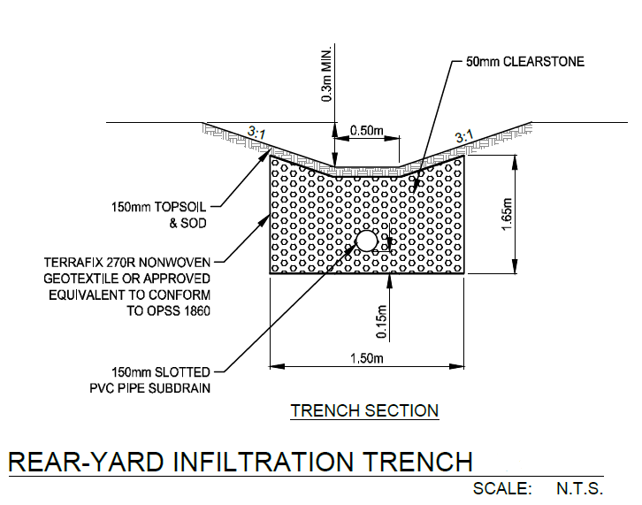

**Inspection and Maintenance:**

Homeowners are encouraged to regularly inspect and maintain trenches to ensure they are functioning properly by doing the following:

• Clean out leaves, debris and accumulated sediment caught in the trench or catch basin inlets and outlets annually or as needed

• Inspect the outlet catch basin lead to ensure flows are successfully draining during a larger storm event

• Check the drawdown time: The anticipated drawdown time for the infiltration trenches is 12 hours, which means water may be visible in the trench up to 12 hours after a storm event is over. Due to the presence of the underdrain, the presence of standing water for more than 12 hours is not anticipated. If standing water is observed in the infiltration trenches 12 hours after the storm event is complete, this indicates a blockage, and an inspection should be conducted.

• Check the maximum ponding depth around the rear yard catch basins. The depth should be 0.26m during the 100 year storm event. If ponding exceeds this amount, this indicates blockage, and an inspection should be conducted.

• Lift the catch basin lid and observe if there is any sediment/debris blocking the pipes. If so, it should be removed immediately.

• Determine if the catch basin requires further cleanout. The homeowner shall obtain a contractor to clean and flush the catch basin and alleviate the blockage. The cost to flush the sewer and clean out the catch basin in 2023 dollars would be a minimum of $1200. A licensed sewer vacuum truck contractor shall be retained by the homeowner. In the event that there is excessive ponding lasting more than 12 hours, and the sewer has been flushed and cleared of any obstructions, the homeowner may need to retain the services of a qualified professional to conduct a geotechnical investigation of the system.

• Provide unobstructed access to the catch basin for any maintenance related to upstream storm sewer or catch basins.

The cross section of the design feature identifying these locations is included as **Figure 3**.

The private monitoring locations can be identified on the Monitoring Location Plan included as **Figure 2**.

Inspection and maintenance logbook forms are included in **Appendix B.**

Figure 2 - Monitoring Location Plan

(Insert plan which highlights relevant LID features)

Figure 3 – Rear Lot Catch Basin Detail

(Insert applicable detail)

Appendix A – Contributing Lot Drainage

Sample lot drainage table:

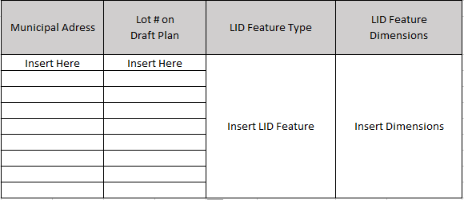

Appendix B – Inspection Template

(Example Inspection checklist)

